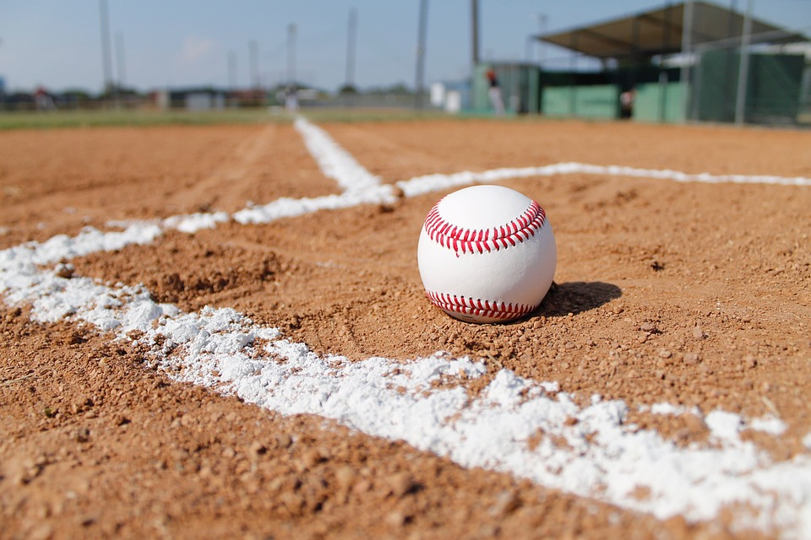**Hello!**

**My name is Laura Roach and I’ll be your child’s 2nd Grade teacher next year. I started teaching in the district in 1994 and moved to the absolute best elementary school in the district in 2016.**

**I am the mother of Ashton, a 2022 Perkins graduate and incoming 7th grader at John Hopkins Middle School. If I’m not at school, you’ll find me cheering him on at any given baseball field in the state of Florida and beyond!**

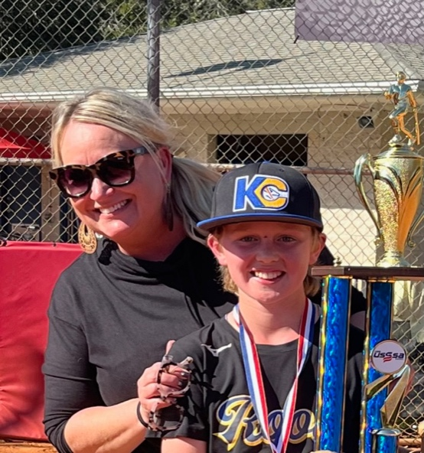**I look forward to working with both you and your child this upcoming school year. Second grade is a fun year of academic, emotional, and social growth.**

**Have a wonderful summer!**

**Ms. Roach**